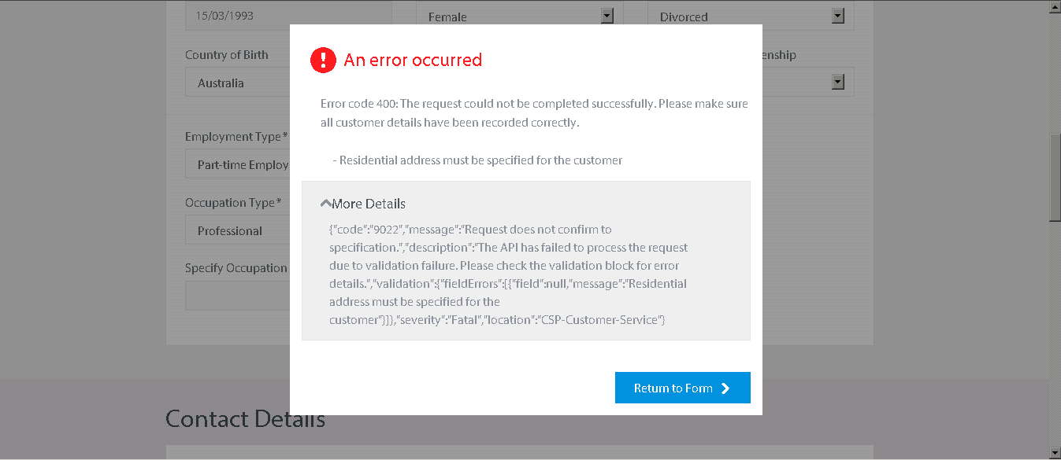

1. **ANZ-Request-ID:**

892a0af0-2e52-11e8-8439-45c1bcb03d09

1. **Remote Address:**

10.52.19.112:443

1. **Request URL:**

https://cspuisit1.service.dev/api/customerservicev2/customers/4024901462

1. **Request Method:**

PUT

1. **Status Code:**

400 Bad Request